



**Administration Report**

**January to March 2020 (Q4/20)**

P.O. Box 40, 44 Main Street

Cobden, Ontario

K0J 1K0

613-646-2282

[www.whitewaterregion.ca](http://www.whitewaterregion.ca/)

Table of Contents

Message from the Chief Administrative Officer 3

Development & Planning 4

Planning 4

Economic Development 4

Tourism 4

Environmental Services 5

Drainage 5

Utilities 5

Water & Wastewater 5

Waste Management 6

General Government 7

Financial Services 7

Legislative Services 8

Asset Management 8

Health & Safety 8

Office of the CAO 9

Parks & Recreation 10

Arenas 10

Recreation Programs 11

Parks & Trails 11

Boat Launches & Beaches 11

Protective Services 12

Building Services 12

By-law Services & Animal Control 12

Fire Services & Permits 12

Emergency Management 13

Public Safety & Policing 13

Transportation Services 14

Administration & Engineering 14

Fleet 14

Roads 14

Budget Report 15

Full-Time Staff Teams 18

# Message from the Chief Administrative Officer

April 30, 2020

One year has passed since the devastating flooding of 2019. To this day, the community recovery committee continues to work with affected residents. We received good news that the Province has approved our claim of over $1 million for our expenses associated with response and road work. The Municipal Emergency Control Group comprised of the Mayor and Reeve, me and senior staff, have monitored the spring Freshet with the assistance of our internal flood response team. The Ottawa River Regulation Planning Board has compared this year’s melt with 2008 and 2018. Luckily, we have not had to deploy sandbags and have 30,000 in reserve.

While we kept an eye on the river and our water bodies, the Township was required to respond quickly to the Covid-19 pandemic. This is an unprecedented emergency that required us to close our facilities to the public, while maintaining essential services, such as road maintenance, water and sewer services, curbside pick up of garbage and recycling, and continued issuance of building permits. This has required us to adapt ensuring our full-time staff team is safe and productive. We were required to adopt new technological solutions. Dog tags can now be purchased online. Some staff are working from home when not reporting to the office to maintain physical distancing measures. We have spread out our roads team to our three garages. Spring work such as pothole patching and gravel grading has occurred as required.

Council decision-making has continued through the pandemic. They met using zoom video-teleconferencing in March and April with more meetings scheduled for May. In a sense, it is business as usual as the 2019 financial statements were presented and some important capital projects carry on. Some cost containment measures are being explored and some relief was approved with the waiver of interest and penalty on outstanding accounts for March and April.

As a Township, we are committed to providing services to our residents, especially in these difficult times. Looking ahead to the second quarter, the Township is examining the gradual resumption of services and reopening of facilities as the threat of Covid-19 slowly subsides.

On behalf of Whitewater Region, I want to thank all frontline workers, including health professionals and paramedics for their dedication especially during these unprecedented times. To the WWR staff team, thanks for your continued commitment and willingness to adapt.

Stay well and safe!

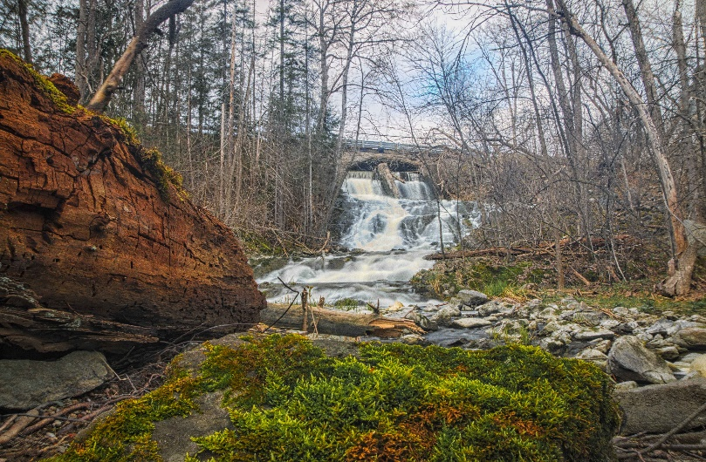

**Robert Tremblay**Chief Administrative Officer

# Development & Planning

Development & Planning includes severances, site plans, zoning and official plan matters, as well as Economic Development & Tourism. Ivan Burton serves as Planner/Economic Development Officer.

## Planning

* A total of 6 Consent and 3 Zoning By-law Amendment applications as well as 1 Private Road Agreement were considered during the quarter and 9 Compliance Reports were issued.
* An application was submitted for the 2020 Rural Economic Development (RED) Program offered by OMAFRA for the preparation of a Business Retention and Expansion Program (BR+E).
* Funding request was submitted, in partnership with the Muskrat Watershed Council, for the Places to Grow funding offered by the OMAFRA for the preparation of a Stormwater Assessment, Planning and Implementation of the Cobden Agricultural Area.
* Assisted in funding submission of the (Fed./Prov.) ICIP Green Stream for the Renewal and Optimization of Beachburg Water Treatment Plant.
* Issued a Letter of Support to Muskrat Watershed Council for their application to the Natural Edge Program for shoreline naturalization in the Muskrat Watershed.
* The preliminary growth projections from the Village and Hamlet Growth Study and Development Charges By-law Review were presented for information purposes.
* Responded to approx. 70 general inquiries relating to zoning, setbacks, applications, approval processes, etc.

## Economic Development

* Organized a Mayor’s Business Breakfast with the Upper Ottawa Valley Chamber of Commerce, originally scheduled for March 24, 2020. The event was postponed due to the pandemic.
* The donation of land in Westmeath (at Gore Line/Rapid Road) was considered by Council for the development of a new parkette. Programming is being reviewed.
* Assisted the CAO in obtaining background/economic impact data relating to the closure of Scotiabank Beachburg Branch.
* Township main street bench renderings were presented to Council for consideration and direction.

## Tourism

* Joe Kowalski made presentation regarding the Ottawa River Provincial Park - Open for Day Use. Council and staff met with Andrea Khanjin, Parliamentary Assistant to the Hon. Jeff Yurek, Minister of MECP, at ROMA. Staff have since reached out to Jonathan Ricci, Policy Advisor and Stakeholder Relations.
* Township approved and submitted a request to host and deliver, with volunteers, one-segment of the 2020 Taste of the Valley.
* Tour de Whitewater presented their plans for 2020; however, the event was later cancelled due to the pandemic, as was the Beachburg Fair.

# Environmental Services

The Environmental Services Division is led by Steve Hodson, Superintendent. The Division is responsible for drainage, utilities, waste & wastewater, as well as waste management, including recycling and curbside pickup. The division is part of Public Works managed by Lane Cleroux.

## Drainage

* Further discussion with Lorne Franklin, Robinson Consulting occurred during Q1 respective to works on the MacLeod Drain as well as delegation of drainage superintendent duties.
* Staff submitted for the OMAFRA Grant on Costs of Employing a Drainage Superintendent.
* Staff attended an OMAFRA Drainage Act Webinar which addressed reduced requirements when seeking approval on municipal drainage works.
* Staff were scheduled to attend a Rural Municipal Drainage Course in Ottawa late in Q1 but the course was cancelled due to Covid-19.

## Utilities

* Discussions occurred with the Ottawa River Power Corporation on the LED streetlight conversion project in LaPasse.
* Streetlight maintenance continues to be completed by Rondeau Electric. An online form was added to the website to report a service request. Units are being upgraded to LED when maintenance occurs.

## Water & Wastewater

* The Township’s three Drinking Water System Licenses are up for renewal. Notification from the Province was received in January.
* A report was brought to Council referencing the 2019 Annual Ministry of Environment, Conservation and Parks (MECP) Drinking Water Inspection Report for the Cobden Drinking Water System during Q1.
* A report was brought to Council referencing the 2019 Annual Drinking Water System Reports submitted to MECP. The annual reports are prepared by the Township’s accredited operating authority, the Ontario Clean Water Agency (OCWA).
* The Cobden Wastewater Treatment Plant 2019 annual report was prepared by OCWA and submitted to MECP.
* Investing in Canada Infrastructure Program (ICIP) Green Infrastructure Stream application was submitted for the Renewal and Optimization of Beachburg Water Treatment Plant.
* Watermain break repairs occurred on Morton Street, Gould Street and John Street in Cobden.
* Cobden WWTP Upgrades contractor expenditures totaled $4,508,906.24 as of March 31 leaving $6,471,093.76 to be completed. There have been 19 change orders to date, totaling 244,392.14.

## Waste Management

* The new curbside collection system for waste got underway beginning January 1, 2020. Residents and businesses can put out two bags of any colour weekly. Those requiring more than two bags per week can still purchase and utilize the Whitewater Region yellow bags at a cost of $5.00 each. The new system is resulting in an increased use of curbside collection as well as decreased traffic at the Landfill Site.
* Two new 40-yard recycling containers were purchased for the Ross Landfill Site. The old ones, no longer fit for hauling, have been put aside. Faught Steel carried out repairs on the access stairs for the containers to ensure their structural integrity and safety.
* 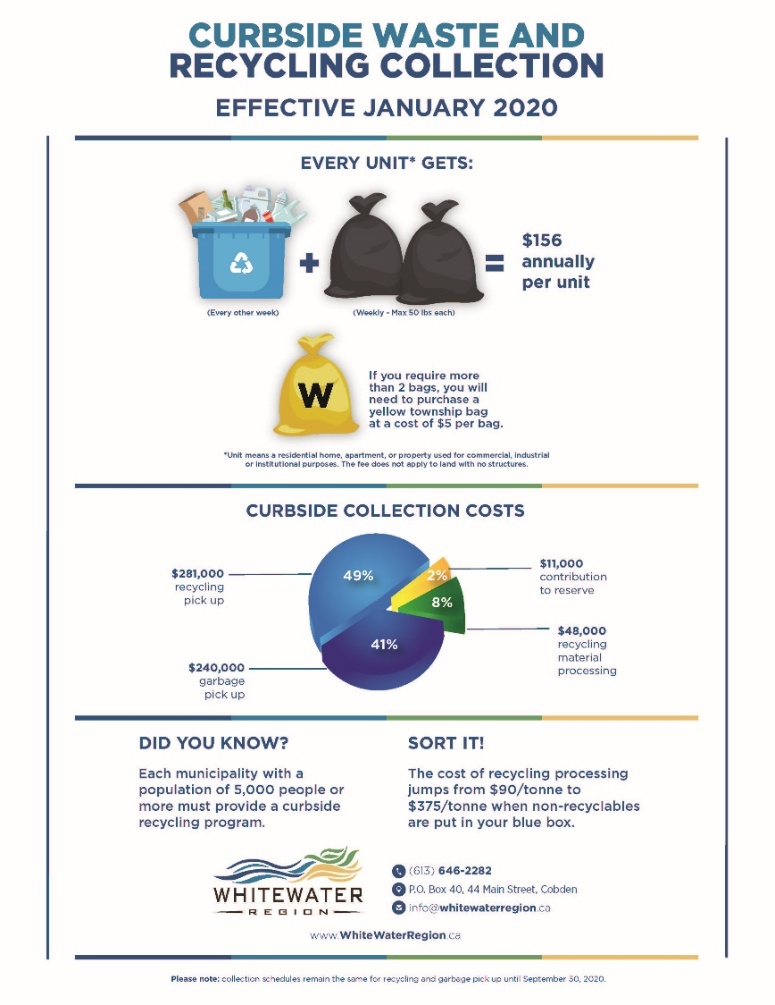New residential waste and recycling calendars and maps, as well as a new fee structure for the Ross Landfill, were all introduced during Q1.

• A report was brought to Council in support of amending two agreements for the provincial municipal hazardous & special waste program. Amendments to the agreements with Stewardship Ontario and Automotive Material Stewardship will enable the Township to continue to receive funding for hazardous materials collected during the two HHW Events held each Spring and Fall.

* The annual HHW Events were booked for May 23 and September 26, 2020. During Covid-19, the May event was cancelled.
* The Ross Landfill was closed to the public late in Q1 as a result of Covid-19. Only residential curb-side collection as well as commercial establishments have been granted access by appointment only.
* The valuation for the potential buy from Ottawa Valley Waste Recovery Centre is proceeding.

# General Government

General Government includes financial and legislative services under the leadership of Sean Crozier, Treasurer/Deputy CAO and Carmen Miller, Clerk. The Office of the CAO provides overall administrative management of the organization.

## Financial Services

* On February 6, Interim Tax bills were mailed out in the amount of $5,288,567.40.
* On February 12, Council delegated their authority to the Assessment Review Board to exercise certain powers and functions with respect to tax applications due to sickness or extreme poverty.
* On February 12, Council appointed Kim Peterson as Deputy Treasurer.
* On March 4, the Township transferred $122,041.87 of utility arrears to taxes for 118 properties.
* On March 5, the first of six utility bills were sent out in the amount of $91,864.11.
* On March 25, Council approved the revised interest rate of 0% for tax, utility and accounts receivable arrears for two months due to the on-going pandemic.
* On March 29, Minister Clark informed Mayor Moore that the Township’s application under the Municipal Disaster Recover Assistance Program for costs associated with the spring 2019 flooding was approved up to $1,110,496.10.
* The 1st installment of the County and School Board Levies were due on March 31st, 2020:
  + County: $803,962.00
  + English Public: $364,875.98
  + English Separate: $75,215.11
  + French Public: $6,119.97
  + French Separate: $17,217.02
* The 2019 year-end audit was completed in quarter 1.
* On March 31, $61,531.04 of the March 5 utility billing remained uncollected. This represented 67% of that billing.
* On March 31, $2,366,762.57 remained uncollected of the interim property tax billing which represented 44.75% of the amount billed. In 2019 42% of the interim levy remained uncollected as of March 31, 2019.
* A summary budget variance report as of March 31 is attached with some notes below:
  + Revenue
    - No budgeted transfer from reserves have occurred.
    - Interim tax billing will not show as revenue until the final billing is calculated.
    - Dog license revenue at 50% of budgeted value.
    - Fire revenue shows debenture proceeds in hand for fire tanker received early 2020.
  + Expenses
    - Emergency measures showing 40% budget used to date as sandbags were purchased.
    - Library and Ross Historical Society operating grants have been sent out.
    - Capital purchase of the scrubber for Parks & Recreation has been purchased.
    - Recreation is showing Cobden Arena detailed design work completed and billed up to end of quarter.

## Legislative Services

* Legislative Services issued 20 Burial Licenses, 2 Lottery Licenses and commissioned 12 documents.
* Council held 7 meetings, considered 23 reports, and enacted 38 by-laws.
* Council had their first successful electronic meeting on March 25. The procedural by-law was updated to allow such meetings during a declared emergency.
* Council passed the Multi-year Accessibility plan which put the Township in compliance with the 2019 provincial legislated requirements.
* Crossing Guards were laid off in early March once Cobden School was closed due to the pandemic.

## Asset Management

* A Summary of sewer infrastructure implemented improvements and/or opportunities within the Village of Cobden was presented to Council providing a range of projects from 2012 to 2019.
* A report was prepared for information purposes regarding Landfill Airspace (remaining capacity) at the Ross Landfill Site.
* The Township entered into an agreement with Snow Country Snowmobile Region for the leasing of municipal property located at 2272 Mineview Road (old Mineview Garage) for a five-year term commencing May 1.
* Previous reports, studies and data are being consolidated.
* Follow up occurred with Public Sector Digest to fully implement the asset management software program.

## Health & Safety

* One member received full JHSC certification.
* Joint H&S committee met in Q1.
* Two firefighters took the online-traffic control course.
* Three active WSIB cases are on-going.
* The revised Health & Safety and Workplace Violence & Harassment Prevention policies were adopted by Council.

## Office of the CAO

* A Volunteer Recognition Policy was adopted by Council. The April recognition event was unfortunately cancelled due to the pandemic, but the awards program is proceeding.
* The 2020-2030 Strategic Plan with detailed 2020 workplan was approved in January.
* The Employee Code of Conduct was established. It was developed through on-going consultation and training with staff on corporate values and competencies.
* The Township’s grant policies were reviewed for recreation and events.
* Corporate insurance renewal saw an increase for 2020 with a higher deductible at $20,000.
* The Local Efficiency Group (LEG) Service Delivery Review was awarded to Dillon Consulting Limited, in partnership with Performance Concepts Consulting.
* The Seniors & Older Adults Task Force presented to Council on its work and preliminary findings and areas of focus.
* The CAO provided support for the community Save our Scotiabank Committee. Council called on the Government of Canada through the Prime Minister, Minister of Finance, Associate Minister of Finance and Minister of Rural Economic Development to implement an immediate moratorium on the closure of rural bank branches to allow for a detailed review by a joint Committee of Parliament.
* A Delegation of Authority Policy was brought forward to deal with administrative matters with reporting. In addition, an Alternative Working Arrangements Policy was established dealing with telework, flex hours and reduced hours.
* 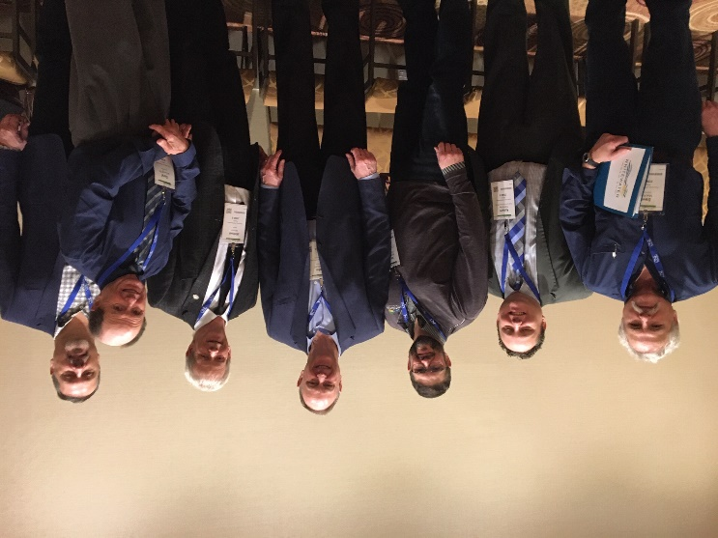CAOs in Renfrew County have kept in touch on a weekly basis during the pandemic to share information and best practices.
* Mr. Tremblay, as Vice-President of the Association of Municipal Managers, Clerks & Treasurers of Ontario participated in committee and board meetings through teleconference.
* Members of Council met with several members of Provincial Cabinet at the annual Rural Ontario Municipal Association (ROMA) Conference in Toronto. A total of seven delegations were carried out.

*Left to Right: Councillor MacKay, CAO Tremblay, Councillor Nicholson, MPP John Yakabuski (Minister of Natural Resources & Forestry), Mayor Moore, Councillor McLaughlin, Councillor Olmstead)*

# Parks & Recreation

The Parks & Recreation Department is led by Jordan Durocher, Manager. The Department is responsible for arenas, parks, boat launches, ball diamonds, beaches, and active transportation. The department works closely with community partners.

## Arenas

* Due to the early closing of arenas due to the covid-19, plant shutdowns took place March 19 in Cobden and Westmeath and March 30 in Beachburg.
* Ice Rentals:
  + Beachburg Arena 363.5/hrs of ice rentals
  + Cobden 493.25/hrs of ice rentals
  + Westmeath 270.5/hrs of ice rentals  
    Total Ice Rentals: 1127.5/hrs

Average hours of usage per day: Beachburg (5), Cobden (6.75), Westmeath (3.5)

Ice Rentals cancelled due to COVID-19:

* + Beachburg Arena 89.5/hrs of ice rentals
  + Cobden Arena 85.0/hrs of ice rentals
  + Westmeath Arena 14.0/hrs of ice rentals  
    Total Ice Rental Cancelations: 188.5/hours of ice rentals  
    **Total Loss of Revenue: $19,210.00**
* Updates were made in the facility booking software to organizations, user group contact info and mailing addresses, rates and staff permissions to access the scheduled bookings.
* Standard Operating Procedures were implemented for a lockout procedure for safe plant operations in all arenas.
* Open House for Cobden Arena Detailed Design
  + Approximately 50 people attended, and drawings were displayed for feedback from attendees and were reviewed by the Architect.
  + User groups were consulted.
  + CAO followed up with Whitewater Region Public Library Board to confirm their desire for space.
  + CAO, Mayor and Reeve met with three members of the Cobden Agricultural Society to address their concerns (continued use of recently acquired park land, upper hall, competition for banquets and weddings, consultation & communication, and no work on their land).
* Staff attended a risk management regional seminar (Arena Refrigeration Plant Compliance Awareness) on March 3 in North Bay, hosted by the Ontario Recreation Facilities Association to discuss potential changes in arenas. Changes being considered include:
  + brine testing directives
  + technical safety recommendations as a result of the Fernie, B.C. incident in October 2017
  + TSSA (Technical Standard Safety Authority) recommendation for refrigeration plant rooms rating based on safety with a scheduled maintenance plan.

## Recreation Programs

* Public Skating saw great attendance in Q1 2020:
  + Beachburg - 775 people
  + Cobden – 270 people
  + Westmeath – 340 people.
* March Break Skates planned for March 16-21 were cancelled due to COVID-19. Sponsorships were secured from St. Andrews Church & Cobden Recreation Association.

## Parks & Trails

* Parks, playgrounds and trails were closed due to the COVID-19 pandemic.
* Signage was made to address the closure and notify the public.

## Boat Launches & Beaches

* Boat Launches were closed due to the COVID-19 pandemic.
* Signage was made to address the closure and notify the public.

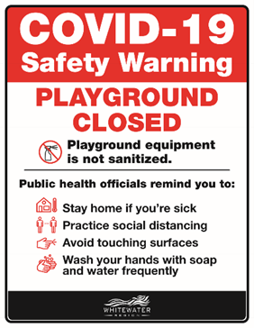

# Protective Services

Protective Services includes the Building Department led by Doug Schultz, Chief Building Official. The CBO is also responsible for animal control and by-law enforcement through contract services. The Whitewater Region Fire Department is managed by Acting Fire Chief Guy Longtin and Deputy Fire Chief Jonathan McLaren. With over 60 volunteer firefighters and five stations, the Department ensures the protection of the area with suppression, education and prevention. OPP matters are also summarized in this section and emergency measures, which are coordinated by the Manager of Public Works as the Community Emergency Management Coordinator (CEMC) and the Clerk as Alternate CEMC.

## Building Services

* 17 permits have been issued in Q1 with 2 for new dwellings,7 septic systems and 1 new dairy barn.
* Total value for Q1 is $2,122,200.00.
* On-going follow up and reminders occurred for building without a permit.

## By-law Services & Animal Control

* A pilot project was approved to issue and pay for dog permits through the Township’s website. Tags can also be purchased at local retailers and through the administration office.
* A meeting occurred with the Renfrew County SPCA on potential partnerships to be explored in the future.
* The early bird rate for dog tags was extended to May 31, 2020.
* Council supported the Security from Trespass and Protecting Food Safety Act, 2019.
* In the first quarter, 7 calls were received due to dogs and 3 property standard issues were investigated.

## Fire Services & Permits

* The Fire Department welcomed Guy Longtin as Acting Fire Chief for the remainder of 2020.
* The department responded to 30 calls in the first quarter of which 12 were fire related, 3 CO alarm calls, 2 rescue calls, 7 false alarms, and 6 miscellaneous calls.
* Station 1 took delivery of the new tanker in January and has placed it in service that same month.
* Training has been put on hold temporarily until we can meet with more than five people due to the pandemic. We are looking at some online training and hopefully we can have something in place early in the next quarter.

## Emergency Management

* The Township is participating in the University of Waterloo's study titled "How disaster feels: the cascading effects of time and experience on perceptions of risk, response and recovery to flooding in Whitewater Region Township".
* Lane Cleroux was appointed as Community Emergency Management Coordinator with Carmen Miller as Alternate.
* The Municipal Emergency Control Group (MECG) held 11 meetings due to COVID-19 between March 15 and 30.
* 20,000 sandbags were ordered and placed in reserve along with left over stock from 2019.

## Public Safety & Policing

* A 2019 update was received form the OPP Policing Bureau. The 2020 estimated Base Services cost is the lowest since 2015 at $183.23 per property. The 2019 Q3 statistical report was received in January.
* The Township is working with its municipal partners within the Renfrew and Upper Ottawa Valley detachments for the development of the mandated Community Safety & Well-Being Plan.



# Transportation Services

The Transportation Services Division is led by Randy Buckwalt, Roads Superintendent. This area includes responsibility for fleet and roads. The division is part of Public Works managed by Lane Cleroux.

## Administration & Engineering

* The Cobden salt structure was completed and placed into service.
* Cameron Street engineering design is on-going.
* Crawford Street preliminary design is completed, and detailed design is on-going.

## Fleet

* Tenders were released for:
  + Front-mounted offset flail mower
  + Slip-in water tank
  + Wheeled excavator
  + Fuel supply
  + 2500 series regular cab truck with dump box and plow for Environmental Services (but deferred after no bids received).

## Roads

* Sand was hauled into replenish the supply of winter supplies at the Mineview yard two times and once to the Westmeath yard.
* Snow was removed in the villages seven times.
* There were 23 weather related events that involved plowing and/or salt/sanding.
* Ditches were opened on various roads that are flood prone areas.
* Crews were busy opening catch basins and pushing back snowbanks in preparation for spring runoff.
* Patching potholes has commenced and is ongoing.

# Budget Report

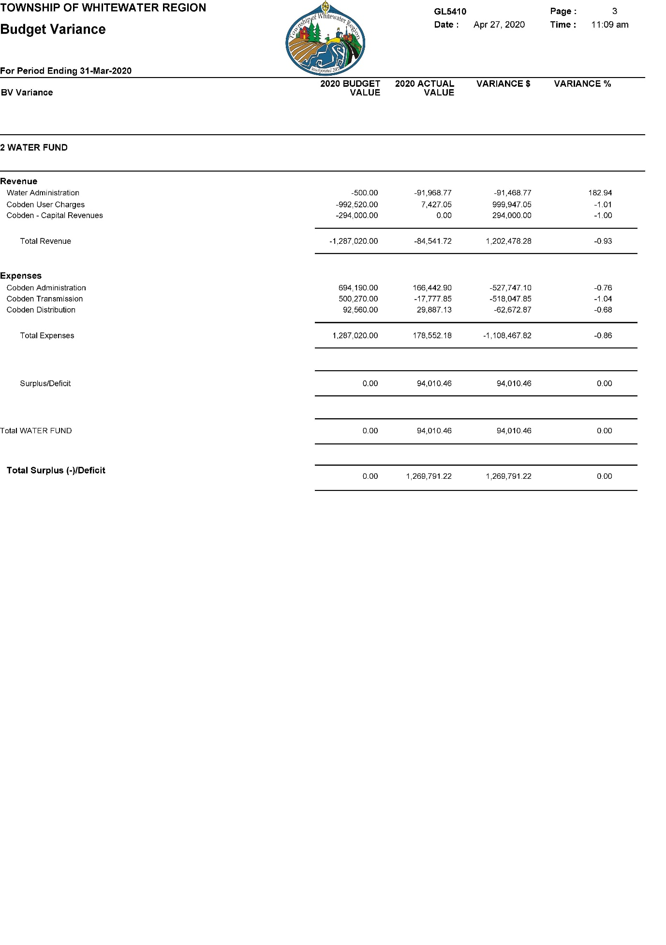

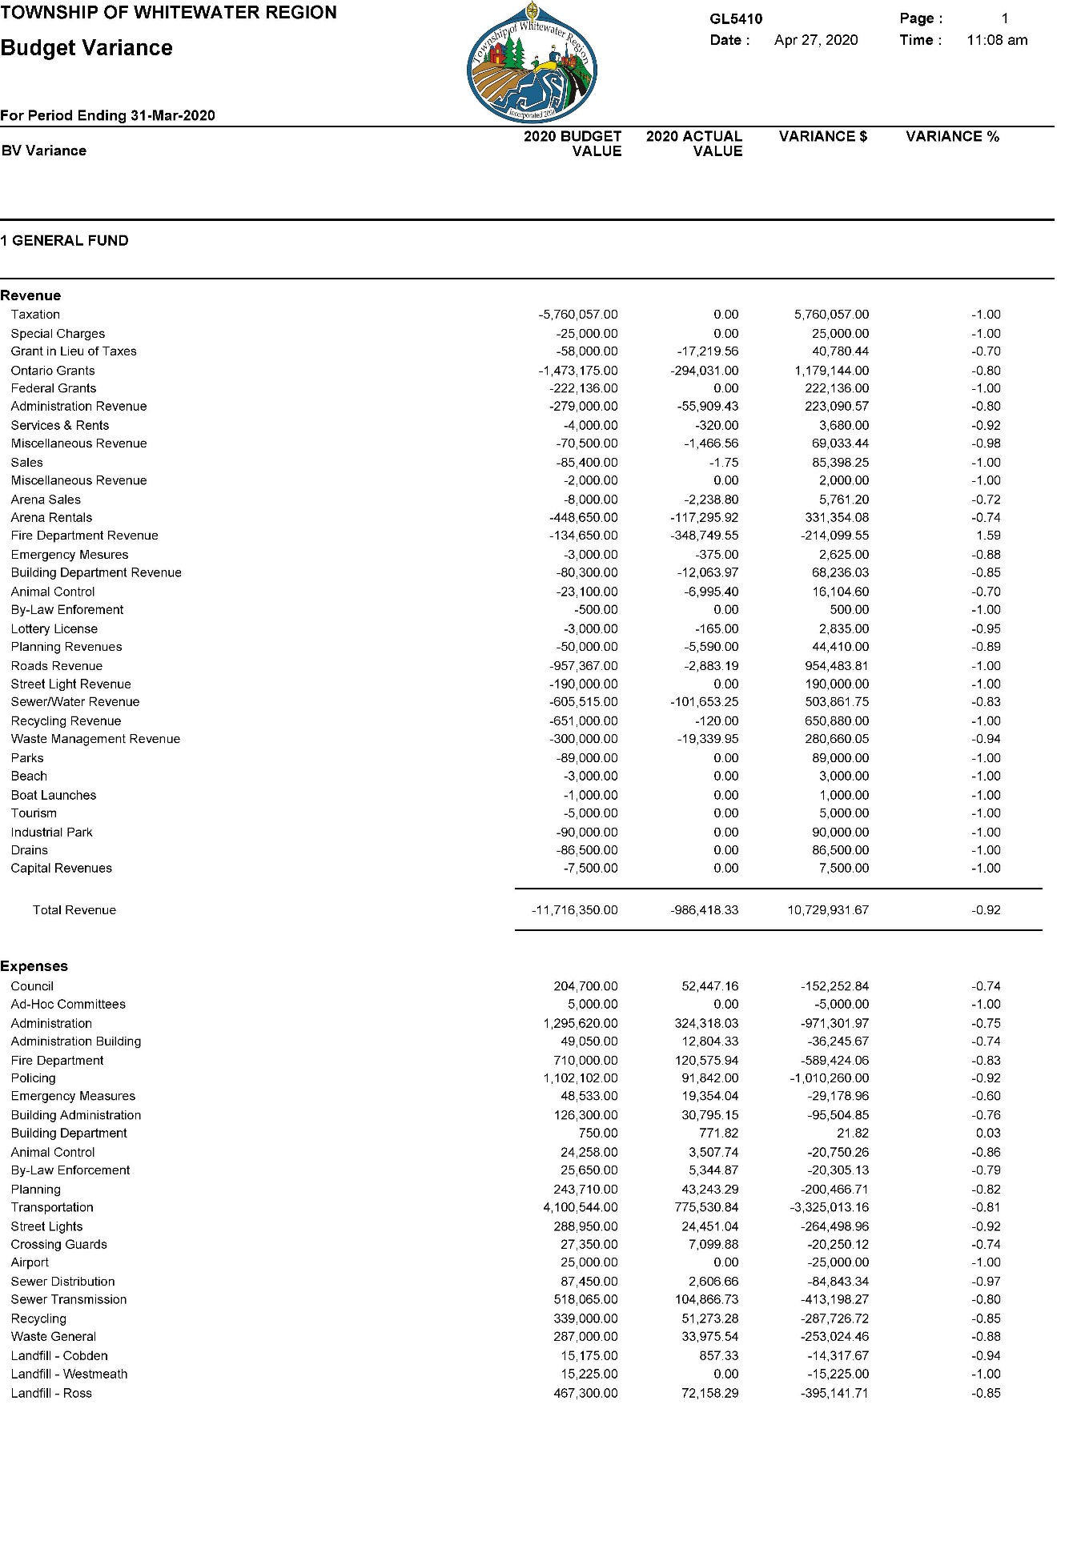  
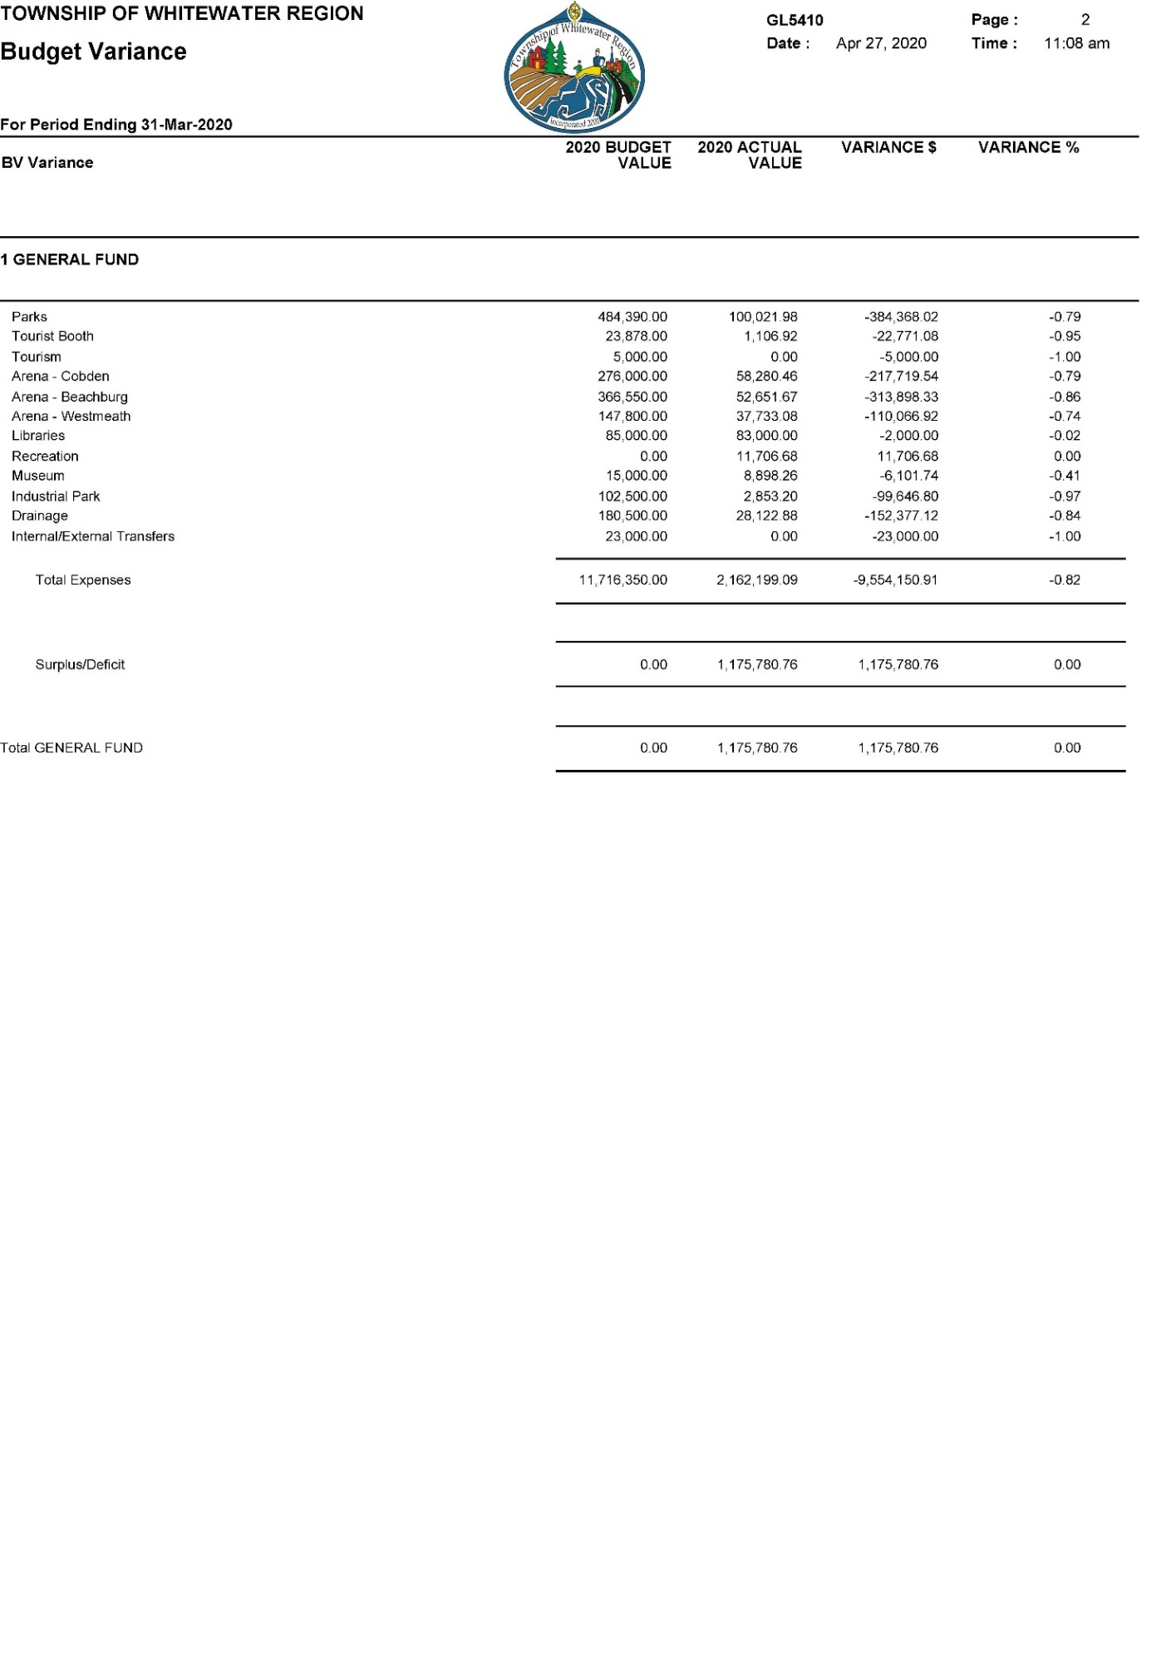

# Full-Time Staff Teams

### General Government

Robert Tremblay, Chief Administrative Officer rtremblay@whitewaterregion.ca

Carmen Miller, Municipal Clerk [cmiller@whitewaterregion.ca](mailto:cmiller@whitewaterregion.ca)

Janet Collins, Asset Management Coordinator [jcollins@whitewaterregion.ca](mailto:jcollins@whitewaterregion.ca)

Sean Crozier, Treasurer/Deputy CAO [scrozier@whitewaterregion.ca](mailto:scrozier@whitewaterregion.ca)

Kim Peterson, Deputy Treasurer [kpeterson@whitewaterregion.ca](mailto:kpeterson@whitewaterregion.ca)  
Marsha Hawthorne, Pay & Benefits Coordinator [mhawthorne@whitewaterregion.ca](mailto:mhawthorne@whitewaterregion.ca) Sandra Moss, Finance Clerk (Purchasing/AP) [smoss@whitewaterregion.ca](mailto:smoss@whitewaterregion.ca)  
Debbie Ready, Finance Clerk (Recreation/AR) [dready@whitewaterregion.ca](mailto:dready@whitewaterregion.ca)

### Development & Planning

Ivan Burton, Planner/EDO [iburton@whitewaterregion.ca](mailto:iburton@whitewaterregion.ca)

### Parks & Recreation

Jordan Durocher, Manager [jdurocher@whitewaterregion.ca](mailto:jdurocher@whitewaterregion.ca)

Arena/Park Operator III:

Al Griffiths [agriffiths@whitewaterregion.ca](mailto:agriffiths@whitewaterregion.ca)

Jerry McIntyre [jmcintyre@whitewaterregion.ca](mailto:jmcintyre@whitewaterregion.ca)

### Protective Services

Doug Schultz, Chief Building Official [dschultz@whitewaterregion.ca](mailto:dschultz@whitewaterregion.ca)

Guy Longtin, Acting Fire Chief glongtin@whitewaterregion.ca

Jonathan McLaren, Deputy Chief [jmclaren@whitewaterregion.ca](mailto:jmclaren@whitewaterregion.ca)

### Public Works

Lane Cleroux, Manager [lcleroux@whitewaterregion.ca](mailto:lcleroux@whitewaterregion.ca)

Steve Hodson, Superintendent of [shodson@whitewaterregion.ca](mailto:shodson@whitewaterregion.ca) Environmental Services

Bill Tripp, Landfill/Facilities Operator [btripp@whitewaterregion.ca](mailto:btripp@whitewaterregion.ca)

Randy Buckwalt, Roads Superintendent [rbuckwalt@whitewaterregion.ca](mailto:rbuckwalt@whitewaterregion.ca)

Terry O’Malley, Mechanic [tomalley@whitewaterregion.ca](mailto:tomalley@whitewaterregion.ca)

Driver/Operator:

Derek Bennett, Roger Blaedow, Dave Brenner, Lindsay Broadhurst, Roy Church, Lucas Hewitt, Darwin Peever, Ward Somerville, Nathan Tubby, Perry Yach, and Anthony Zadow.